# A STUDY OF TEACHER-STUDENT RELATIONSHIP AND ITS EFFECTIVENESS AT SECONDARY LEVEL

**ADEEN AMJAD**

**BO651100**

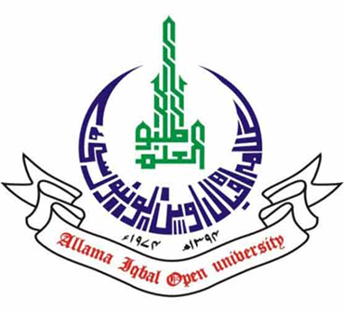

**ALLAMA IQBAL OPEN UNIVERSITY, ISLAMABAD**

May, 2019

|  |
| --- |
|  |